**PRACTICAL – 1.1**

**AIM:**

**Installation & Configuration of Android Studio. Along with its all major Gradle, SDK, AVD etc.**

**THEORY:**

1. **Android Studio**
   * As we know Android world is increasing day by day. Billions of Android apps has been published on Google Play store. So it is the need of time that we should learn some basics of Android development. Android Studio is an IDE (Integrated Development Environment) for Android application development.
2. **Features of Android Studio**
   * Following are some interesting features of Android Studio:
   * It provides a flexible Gradle-based build system.
   * It also support C++ and NDK
   * Run your app without building a new APK.
   * Provides a virtual device to run and test your app
3. **Installation**
   * Follow steps below for complete installation and configuration of Android Studio.

**Step 1)** Download Android Studio

You can download Android Studio from this link or go to developer.android.com homepage and search for downloads. Choose appropriate platform either for Windows, Mac or Linux. Following are the pre requirements for windows operating system.

->Pre-requirements

Microsoft windows 7/8/10 (32 or 64 bits)

Minimum 3GB RAM (recommended 8GB)

2GB disk space

1280 x 800 minimum screen resolution size

Intel processor for accelerated emulator

Android SDK

**Step 2)** Run .exe file

Now the next step is to launch .exe file you just download. Following screen will appear

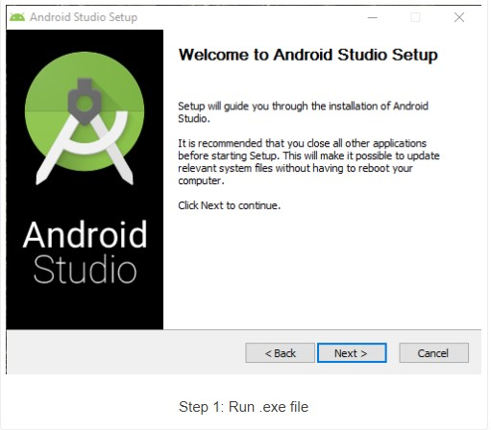

Click next and select Android SDK checked if you dont have it already. Better is to leave the default settings.

Make sure Android virtual device is also checked.

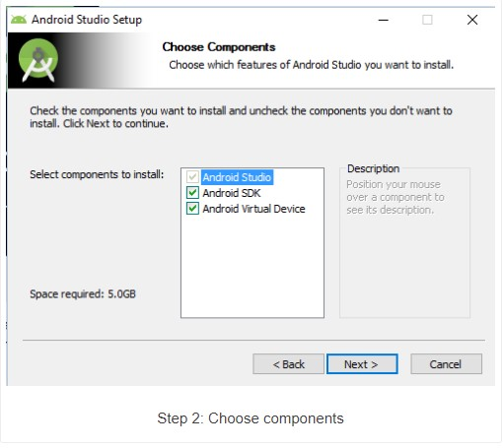

Next step is to accept license and agreement. Click on I Agree

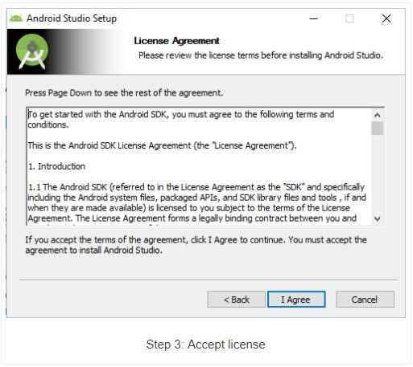

Next step is to set location of installation. Please make sure your disk has minimum required space before clicking on Next. For Android Studio installation location must have at least 500MB free space. For Android SDK installation, selected location must have at least 3.25GB free space.

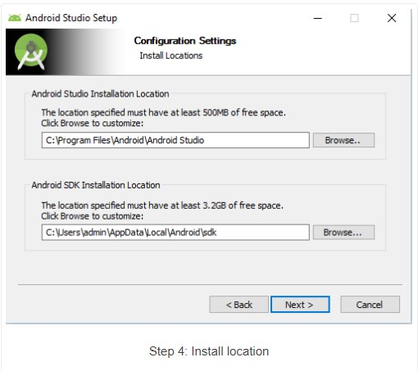

Next step is to choose the start menu folder, where you want to create shortcut. If you dont want to create a shortcut just mark Do not create shortcut.

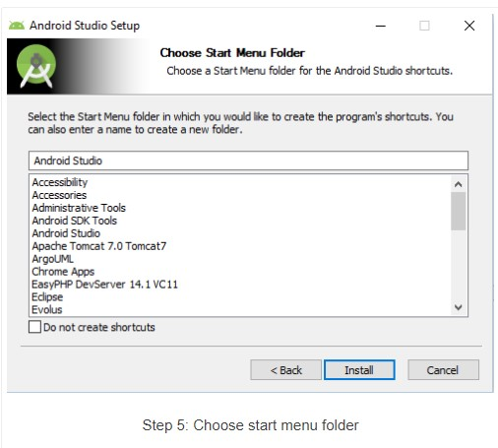

And hit Install button.

It will start installation. Once its done following window will appear.

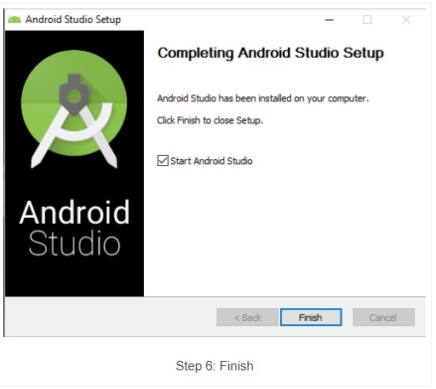

This informs you installation has completed. Click Finish. Make sure Start Android Studio is checked. Following splash screen of Android Studio will appear.

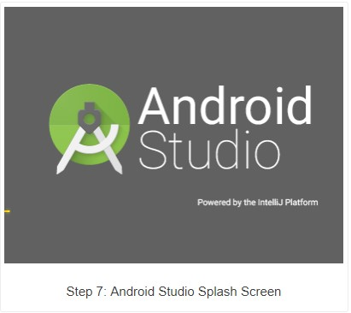

**Step 3)** Configure Android Studio

When you run it for the first time it will ask for Android Studio settings.

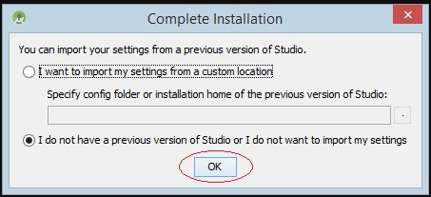

If you don’t have any previous settings click on the second option Select a theme and click next.

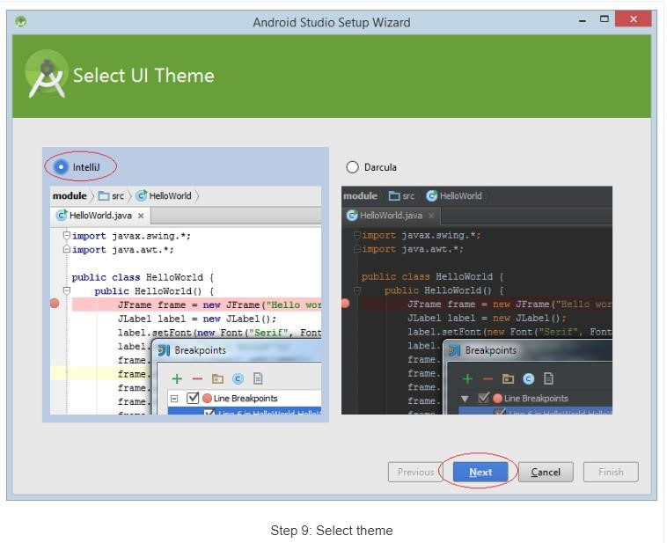

At the very first run it needs to download some necessary components, wait till it completes. And its all done.

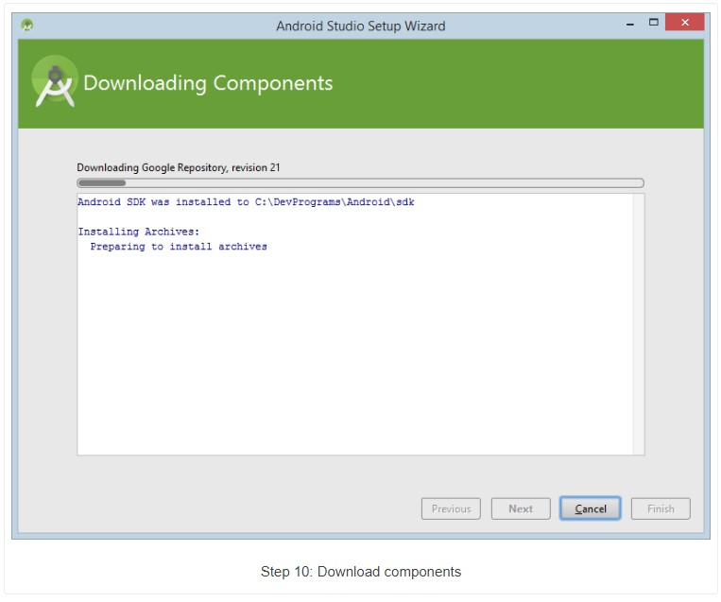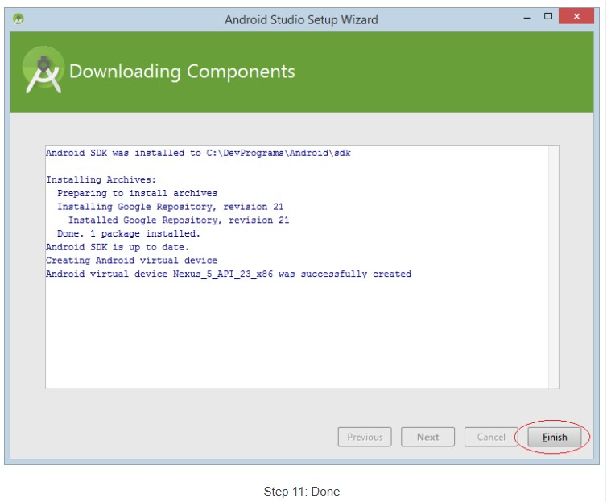

Click on Finish and start building your Android apps.

1. Gradle

• Gradle implements a concept referred to as convention over configuration. This simply means that Gradle has a pre-defined set of sensible default configuration settings that will be used unless they are overridden by settings in the build files. This means that builds can be performed with the minimum of configuration required by the developer. Changes to the build files are only needed when the default configuration does not meet your build needs.

1. SDK

• The Android SDK (software development kit) is a set of development tools used to develop applications for Android platform. The Android SDK includes the following: o Required libraries o Debugger o An emulator

* + - Relevant documentation for the Android application program interfaces (APIs) o Sample source code
    - Tutorials for the Android OS

1. AVD

• An Android Virtual Device (AVD) is a configuration that defines the characteristics of an Android phone, tablet, Wear OS, Android TV, or Automotive OS device that you want to simulate in the Android Emulator. The AVD Manager is an interface you can launch from Android Studio that helps you create and manage AVDs.

